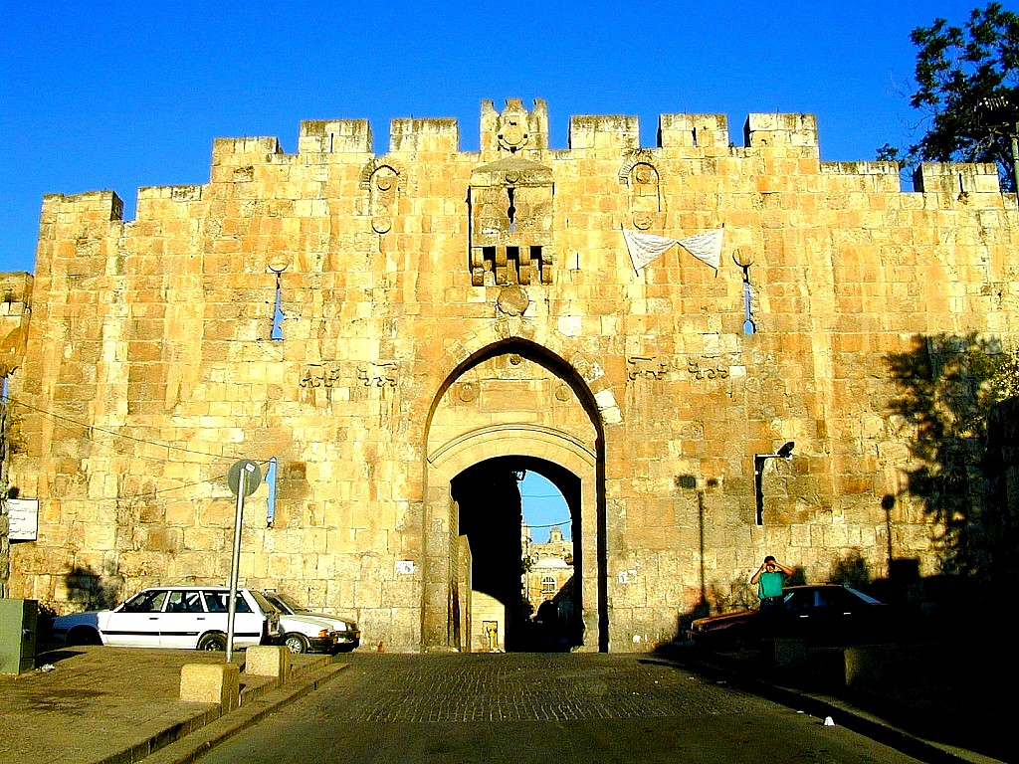
Lutheran Hour Recording Tour
Israel and Palestine

Classroom Devotional Helps
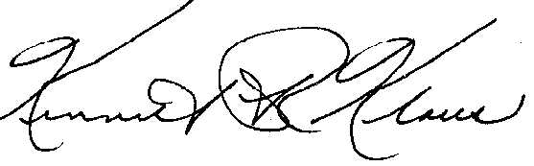
Dear Co-workers in Christ
Greetings and grace from the Babe of Bethlehem, the Christ of the cross! For twenty-five, of my twenty-eighty years in the parish, I was blessed to be a pastor with a parochial school. That, coupled with the assistance of dedicated volunteer teachers made working with the lambs of the church a wonderful experience.
During those years I was amazed by the many different, and creative, approaches that teachers brought to their classroom. That is why this devotional booklet is designed to offer you some suggestions. It was created to save you valuable preparation time, and to allow your students more fully participate in the Lutheran Hour Ministries Israel and Palestine recording tour. Please feel free to use, reproduce, and modify as much, or as little of the material, as suits your purpose.
As you may know, Lutheran Hour Ministries is, with this program, trying to revive the relationship we have enjoyed in the past with our schools. This year we will be traveling to the “Holy Land” for the purpose of recording the 2005 Christmas and Easter broadcasts for The Lutheran Hour. In years to come, if the program meets with acceptance, we shall be touring Egypt, Asia Minor (Turkey), Italy, Germany and Greece. The future, as always, we leave in the Lord’s hands.
This booklet includes devotions which correspond to the days of our pilgrimage. Each day features one of the places our group will be visiting. There will be more information on each of the se places on our WEB page.
Lastly, the Scripture passages are from the NIV; the hymns are from The Lutheran Hymnal. As stated before, please use that which is best for your students.
In Christ, I remain, His servant and yours,

Kenneth R. Klaus, speaker for Lutheran Hour Ministries

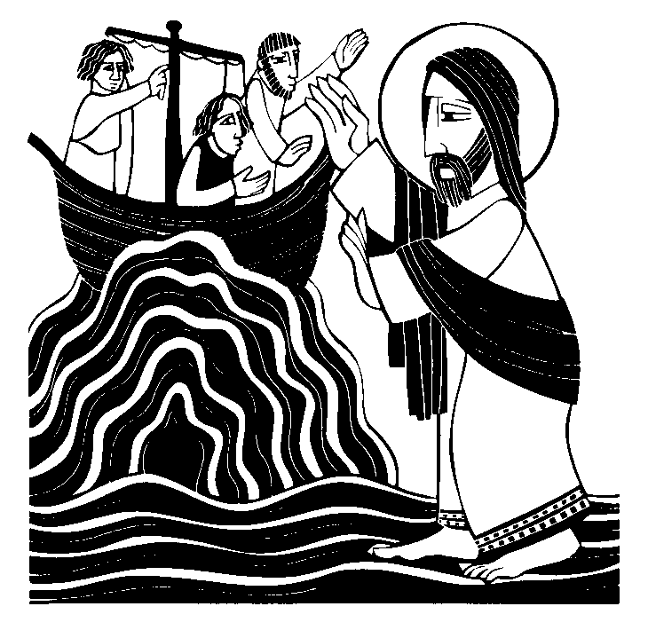
Day #1

Focus On: Having Faith

Theme: The student will understand we can be at peace if we keep our eyes on Jesus.

Scripture: Matthew 14: 25-33
During the fourth watch of the night Jesus went out to them, walking on the lake. ²⁶When the disciples saw him walking on the lake, they were terrified. “It’s a ghost,” they said, and cried out in fear.
²⁷But Jesus immediately said to them: “Take courage! It is I. Don’t be afraid.”
²⁸“Lord, if it’s you,” Peter replied, “tell me to come to you on the water.”
²⁹“Come,” he said.
Then Peter got down out of the boat, walked on the water and came toward Jesus. ³⁰But when he saw the wind, he was afraid and, beginning to sink, cried out, “Lord, save me!”
³¹Immediately Jesus reached out his hand and caught him. “You of little faith,” he said, “why did you doubt?”
³²And when they climbed into the boat, the wind died down. ³³Then those who were in the boat worshiped him, saying, “Truly you are the Son of God.”

Hymn: TLH #649
1. Jesus, Savior, pilot me Over life's tempestuous sea;
Unknown waves before me roll,
Hiding rock and treacherous shoal.
Chart and compass come from Thee:
Jesus, Savior, pilot me.

2. As a mother stills her child,
Thou canst hush the ocean wild;
Boisterous waves obey Thy will
When Thou say'st to them, "Be still!"
Wondrous Sovereign of the sea, Jesus, Savior, pilot me.

3. When at last I near the shore,
And the fearful breakers roar
'Twixt me and the peaceful rest,
Then, while leaning on Thy breast,
May I hear Thee say to me, "Fear not, I will pilot thee."

Devotional Help:
What You Will Need:
Some things that float; some things that sink in water
The lesson
The other day I watched a man on television. He was talking about things that float… and things that sink. I was surprised. Some things I thought would float, didn’t. Some things I thought would sink, bobbed around on the top of the water.
I thought it was so cool, I wanted to try it with you. I’ve got some things here, and I want you to tell me: will it sink or float.
Here’s a pencil. Will it float, or sink. It’s made of wood. Most wood floats. But the pencil has some graphite in it, and this metal band around the eraser. Let’s see the hands of t hose who think the pencil will float? Now the hands of the ones who think the pencil will sink. Try it.
Most of you got that one right.
Here’s two balls. One is a tennis ball…one is a golf ball. Will they both float? Will they both sink? Will one float and the other sink? Which one will do what? (Take a poll of opinions.)
You can do this as long as you want. You can let the children pick a couple of things and guess. Float or sink. When you’ve had enough, you can ask:
“My question is, ‘are you a floater, or are you a sinker?’
No, I’m not going to get a big tub of water, or take you down to the swimming pool and throw you into the water. I’m asking whether you sink, or float spiritually.
A long time ago, when Jesus was on earth, He went off, by Himself to pray. His disciples went sailing on the Sea of Galilee. We’re going to see more about the Sea of Galilee with some of our friends at The Lutheran Hour who are touring on the very lake where the disciples were.
Sometimes, on this large lake, storms come up quickly. That’s what happened to the disciples. They were out on the boat, a storm came up and they were afraid they would sink and never be heard from again.
That’s when Jesus did something very unexpectedly. Does anyone know what it was?
Jesus walked on the water. Right! Now I can swim, and some of you can swim, but unless the water is frozen, we can’t walk on it. Only Jesus can do that.
At first, when the disciples saw Him coming, they thought it had to be a ghost. They found it easier to believe what they were seeing was a ghost rather than thinking it was Jesus. After a while, they saw it was Jesus, and one of the disciples, Peter, said, ‘Jesus, can I walk on the water to You?” Jesus said, ‘Sure, come on.”
Peter got out of the boat and, looking at Jesus, actually was able to take some steps on the water. But then, he looked around and saw the waves and heard the wind, and he asked himself, ‘What am I doing? I’m afraid.’ That’s when Peter started to sink. Probably would have drown, if Jesus hadn’t saved him.
When Peter got back into the boat with Jesus, and the storm stopped, Jesus said, ‘You need to have faith.’
And we do. So, are you a sinker, or a floater? What makes the difference. Well, I think the difference is whether we look at Jesus for help, or whether we look at our problems and get scared. I think we all ought to be floaters, don’t you.

Prayer:
Dear Lord Jesus, sometimes we look at the storms of life, the problems we have, the things we’re afraid of, and we start to sink. We get sad, we get worried. Help us, in faith, to look to You for help. With You we don’t have to be afraid. With You, we know that we can carry our problems and come out, OK. When we do get scared Lord, when we do start to sink, please rescue us. In Your Name. Amen.

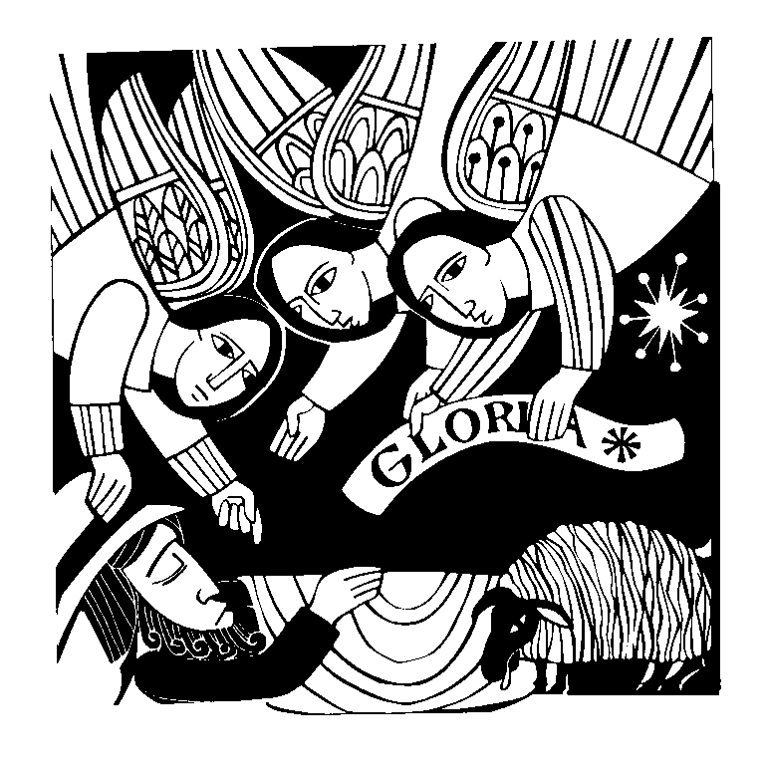
Day #2

Theme: The students may value, and respect the Savior Who was born tos save us.

Focus On: Bethlehem

Scripture: Acts 2: 1-18
¹In those days Caesar Augustus issued a decree that a census should be taken of the entire Roman world. ²(This was the first census that took place while Quirinius was governor of Syria.) ³And everyone went to his own town to register.
⁴So Joseph also went up from the town of Nazareth in Galilee to Judea, to Bethlehem the town of David, because he belonged to the house and line of David. ⁵He went there to register with Mary, who was pledged to be married to him and was expecting a child. ⁶While they were there, the time came for the baby to be born, ⁷and she gave birth to her firstborn, a son. She wrapped him in cloths and placed him in a manger, because there was no room for them in the inn.
⁸And there were shepherds living out in the fields nearby, keeping watch over their flocks at night. ⁹An angel of the Lord appeared to them, and the glory of the Lord shone around them, and they were terrified. ¹⁰But the angel said to them, “Do not be afraid. I bring you good news of great joy that will be for all the people. ¹¹Today in the town of David a Savior has been born to you; he is Christ the Lord. ¹²This will be a sign to you: You will find a baby wrapped in cloths and lying in a manger.”
¹³Suddenly a great company of the heavenly host appeared with the angel, praising God and saying, “Glory to God in the highest, and on earth peace to men on whom his favor rests.”
¹⁵When the angels had left them and gone into heaven, the shepherds said to one another, “Let’s go to Bethlehem and see this thing that has happened, which the Lord has told us about.” ¹⁶So they hurried off and found Mary and Joseph, and the baby, who was lying in the manger. ¹⁷When they had seen him, they spread the word concerning what had been told them about this child, ¹⁸and all who heard it were amazed at what the shepherds said to them.

Hymn: TLH #647
1. O little town of Bethlehem,
How still we see thee lie!
Above thy deep and dreamless sleep
The silent stars go by; Yet in thy darkness shineth
The everlasting Light;
The hopes and fears of all the years
Are met in thee tonight.

2. For Christ is born of Mary,
And fathered all above,
While mortals sleep, the angels keep
Their watch of wondering love.
O morning stars, together Proclaim the holy birth
And praises sing to God, the King,
And peace to men on earth.

3. How silently, how silently,
The wondrous Gift is given!
So God imparts to human hearts
The blessings of His heaven.
No ear may hear His coming, But in this world of sin,
Where meek souls will receive Him still,
The dear Christ enters in.

4. O holy Child of Bethlehem,
Descend to us, we pray; Cast out our sin and enter in,
Be born in us today. We hear the Christmas angels
The great glad tidings tell:
Oh, come to us, abide with us, Our Lord Immanuel!

Devotional Help:
You Will Need:
A baby’s name book OR a dictionary with an index of name meanings.
Lesson
How many of you like your name? Sometimes we do… sometimes we don’t. We certainly don’t like names when people can change them a little bit and make fun of them, do we?
How do you think you got your name? Was anybody here named after a father, or mother, or grandparent? Maybe some of you were named because your parents liked the sound of it; or maybe they respected somebody who had that name before you. Parents spend a lot of time picking a name that they hope will be just right for you.
It’s not an easy thing to do. That’s why there are actually books that you can buy, or get from the library which help us. They tell us how to say a name, and what that name means.
How many of you already know what your name means? (Ask for definitions) I looked for the meaning of my name. My name, _________ means _________. Maybe you thought my name was “teacher.” I wonder if we could find the meaning to some of your names in here? Let’s give it a try, shall we? If we can’t find your name here, don’t be upset. You can go home and ask your mother, or father. They can probably tell you.
I know of one couple who never had to name their Baby. Somebody did it for them. Now, normally, that might not be a good idea. You don’t want just anybody picking out a name for your child. But this time it was OK.
The mother of the Baby was Mary. Mary’s husband was Joseph. He was going to help raise this new Baby. At any rate, they didn’t have to pick a Name. God did it for them. Do you know what Name God picked for His son? (Wait for Jesus.)
Jesus. Do you know what JESUS means? It means Savior. That’s a very special Name. I couldn’t be a Savior, and you couldn’t be a Savior, even your mother and father can’t be Saviors. Only Jesus, Who was born in Bethlehem, a little city, far away, could have that name.
He is our Savior. He saved us from our sins, and from the devil, and even from death. In fact, there is no other Name in the world which can save.
Today, our friends on The Lutheran Hour tour are going to be visiting Bethlehem. They are going to show us some pictures of the place where some people believe Jesus was born. (Although it looked very different back then.)
(NOTE: It is quite possible that your children are not acquainted with The Lutheran Hour. If you have WEB access, you can let them listen to a broadcast at: http://www.lutheranhour.org/

Prayer:
Dear Lord Jesus, we give thanks that we are special, and we have a special name. Most of all we give thanks for You, and the Name Your Father in heaven gave you. We rejoice, dear Lord, that You were born to save us from our sins. In Your special Name we pray. Amen.

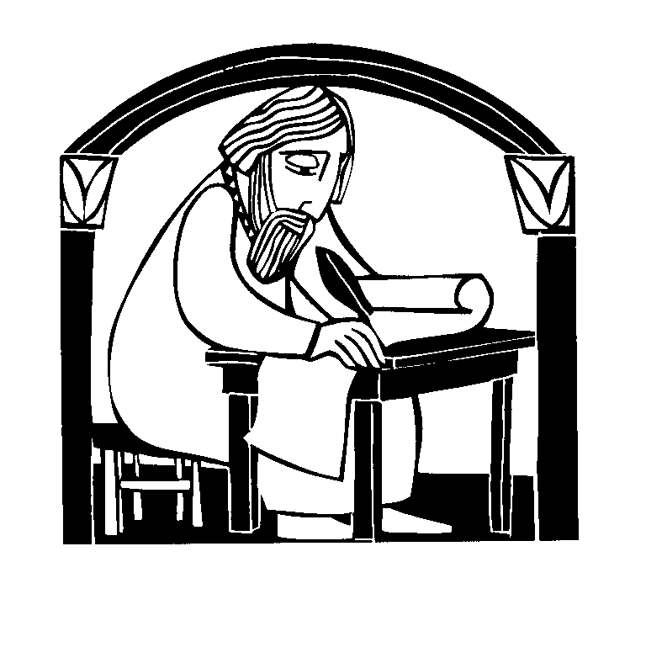
Day #3

Theme: We want the students to know that the Lord watches over His Word, and we can trust everything it says as being true.

Focus On: Qumram

Scripture:
2 Timothy 3: 16-17
All Scripture is God-breathed and is useful for teaching, rebuking, correcting and training in righteousness, ¹⁷so that the man of God may be thoroughly equipped for every good work.
2 Peter 1:21
²¹For the prophecy came not in old time by the will of man: but holy men of God spake as they were moved by the Holy Ghost.
Matthew 5: 17-19
¹⁷“Do not think that I have come to abolish the Law or the Prophets; I have not come to abolish them but to fulfill them. ¹⁸I tell you the truth, until heaven and earth disappear, not the smallest letter, not the least stroke of a pen, will by any means disappear from the Law until everything is accomplished. ¹⁹Anyone who breaks one of the least of these commandments and teaches others to do the same will be called least in the kingdom of heaven, but whoever practices and teaches these commands will be called great in the kingdom of heaven

Hymn: TLH #381
1. I know my faith is founded
On Jesus Christ, my God and Lord;
And this my faith confessing
Unmoved I stand upon His Word.
Man's reason cannot fathom
The truth of God profound; Who trusts her subtle wisdom
Relies on shifting ground. God's Word is all-sufficient,
It makes divinely sure, And trusting in its wisdom,
My faith shall rest secure.

2. Increase my faith, dear Savior,
For Satan seeks by night and day To rob me of this treasure
And take my hope of bliss away.
But, Lord, with Thee beside me, I shall be undismayed;
And led by Thy good Spirit, I shall be unafraid.
Abide with me, O Savior, A firmer faith bestow;
Then I shall bid defiance To every evil foe.

3. In faith, Lord, let me serve Thee;
Though persecution, grief and pain
Should seek to overwhelm me,
Let me a steadfast trust retain; And then at my departure
Take Thou me home to Thee And let me there inherit
All thou hast promised me.
In life and death, Lord, keep me
Until Thy heaven I gain, Where I by Thy great mercy
The end of faith attain.

Devotional Help:
You Will Need
A roadmap – one of your church/school can be run off the computer. Go to http://www.mapquest.com/ and enter the address.
Lesson
All of you have seen a map before. Maps tell us how to get from where we are, to where we’re going. People depend a great deal on maps… about the only people who don’t are explorers. They go where there are no maps, and one of the most important things they do is make a map for those who will be coming after them.
This map is a map of ___________________. Look at all the roads, and streets. There are big roads, and little roads. They are alleys and super highways.
Now, how do you think this map would look if it were 100 years old? Do you think, 100 years ago there were all these streets? Probably not. That’s because maps change. New roads get built, and old roads get forgotten. That’s why you want to have the newest map you can get.
I can show you one map that never changes. That’s the map of God’s Holy Word, the Bible. It is God’s map that shows us how sinners can get forgiven through faith in Jesus, and get to heaven. We follow Jesus, the same way people did 100 years ago, or 1,000 years ago. If you want to get to heaven, we have to follow God’s map – the Holy Bible
Of course, some people say that there are mistakes in God’s map. There are no mistakes that would get you lost. The people from The Lutheran Hour pilgrimage are going to a place called Qumram (say: KOOM-ram). This is a place where people spent their time copying the Bible, God’s map, by hand.
Do you think you would like to do a job like that? Would you want to draw up a map as big as the Bible? It was hard work. They had to make sure they did a good job. And they did.
In a cave, we found part of the Bible that they buried (it was worn out.). It was thousands of years old…. Even though a lot of people copied the Bible over those years, the mistakes were few.
That’s because God wanted us to know we can always believe His road map to heaven. He wanted us to know it was true and could be trusted.

Prayer:
Dear Father in heaven, without maps we get lost. Without your Word, we would also be lost. We give thanks that You have made sure that we can get to heaven by giving us the map of the Bible which we can trust. In Jesus’ Name we give thanks. Amen.

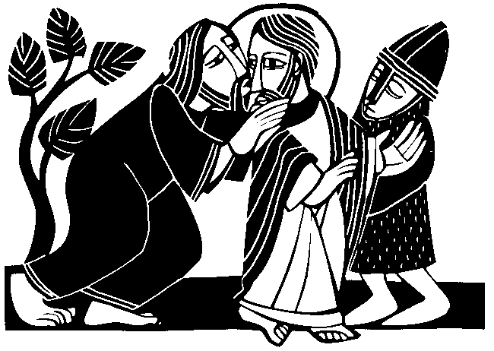
Day #4

Theme: We want the students to see the great love of Jesus Who was betrayed by a friend so we would always be loved by our Father in heaven.

Focus On: Mount Of Olives

Scripture: Matthew 26: 36-56
³⁶Then Jesus went with his disciples to a place called Gethsemane, and he said to them, “Sit here while I go over there and pray.” ³⁷He took Peter and the two sons of Zebedee along with him, and he began to be sorrowful and troubled. ³⁸Then he said to them, “My soul is overwhelmed with sorrow to the point of death. Stay here and keep watch with me.”
³⁹Going a little farther, he fell with his face to the ground and prayed, “My Father, if it is possible, may this cup be taken from me. Yet not as I will, but as you will.”
⁴⁰Then he returned to his disciples and found them sleeping. “Could you men not keep watch with me for one hour?” he asked Peter. ⁴¹“Watch and pray so that you will not fall into temptation. The spirit is willing, but the body is weak.”
⁴²He went away a second time and prayed, “My Father, if it is not possible for this cup to be taken away unless I drink it, may your will be done.”
⁴³When he came back, he again found them sleeping, because their eyes were heavy. ⁴⁴So he left them and went away once more and prayed the third time, saying the same thing.
⁴⁵Then he returned to the disciples and said to them, “Are you still sleeping and resting? Look, the hour is near, and the Son of Man is betrayed into the hands of sinners. ⁴⁶Rise, let us go! Here comes my betrayer!”
⁴⁷While he was still speaking, Judas, one of the Twelve, arrived. With him was a large crowd armed with swords and clubs, sent from the chief priests and the elders of the people. ⁴⁸Now the betrayer had arranged a signal with them: “The one I kiss is the man; arrest him.” ⁴⁹Going at once to Jesus, Judas said, “Greetings, Rabbi!” and kissed him.
⁵⁰Jesus replied, “Friend, do what you came for.”
Then the men stepped forward, seized Jesus and arrested him. ⁵¹With that, one of Jesus’ companions reached for his sword, drew it out and struck the servant of the high priest, cutting off his ear.
⁵²“Put your sword back in its place,” Jesus said to him, “for all who draw the sword will die by the sword. ⁵³Do you think I cannot call on my Father, and he will at once put at my disposal more than twelve legions of angels? ⁵⁴But how then would the Scriptures be fulfilled that say it must happen in this way?”
⁵⁵At that time Jesus said to the crowd, “Am I leading a rebellion, that you have come out with swords and clubs to capture me? Every day I sat in the temple courts teaching, and you did not arrest me. ⁵⁶But this has all taken place that the writings of the prophets might be fulfilled.” Then all the disciples deserted him and fled.

Hymn: TLH #446
1. Rise, my soul, to watch and pray,
From thy sleep awaken;
Be not by the evil day Unawares o'ertaken.
For the Foe, Well we know, Oft his harvest reapeth
While the Christian sleepeth.

2. Watch against the devil's snares
Lest asleep he find thee; For indeed no pains he spares
To deceive and blind thee. Satan's prey
Oft are they Who secure are sleeping
And no watch are keeping.

3. Watch! Let not the wicked world
With its pow'r defeat thee.
Watch lest with her pomp unfurled
She betray and cheat thee. Watch and see
Lest there be Faithless friends to charm thee,
Who but seek to harm thee.

4. Watch against thyself, my soul,
Lest with grace thou trifle; Let not self thy tho'ts control
Nor God's mercy stifle. Pride and sin Lurk within
All thy hopes to scatter; Heed not when they flatter.

5. But while watching, also pray To the Lord unceasing.
He will free thee, be thy stay, Strength and faith increasing.
O Lord, bless In distress And let nothing swerve me
From the will to serve Thee.

6. Therefore let us watch and pray,
Knowing He will hear us As we see from day to day
Dangers ever near us, And the end Doth impend--
Our redemption neareth When the Lord appeareth.

Devotional Help:
You Will Need:
A few valentines and a cross.
Lesson
Valentine’s Day is a very long way off, isn’t it? This is the month of November and Valentine’s Day comes, does anybody know when? Valentine’s day comes in February.
Now, I’d like to ask, what is Valentine’s Day all about? It’s to tell somebody you love them, isn’t it? Now there are all kinds of ways we tell people that on Valentine’s Day? What are some of the Valentine gifts you might share with someone?
You could make a Valentine’s Card, couldn’t you. That would be special. How about writing somebody a poem? Some people give a bouquet of roses, or some candy. Most people give out Valentine’s cards like this, don’t they? I know one father who even gave his little girl a pony for a Valentine’s Day gift. That would be pretty special, wouldn’t it.
Well, I’d like to show you the most beautiful gift of love that I’ve ever seen. It is…. A CROSS. That’s right, a cross. Jesus showed me how much He loved me by living for me, and being betrayed for me, for suffering for me, and for you, too.
It’s a hard thing to have a friend betray you, but Jesus still loved that man who turned Him over to His enemies. He still loves us, even though we sin against Him all the time. Jesus showed His love for us by suffering and dying on the cross.
Today, our friends on The Lutheran Hour pilgrimage are going to pay a visit to the Garden of Gethsemane. That’s where Jesus prayed, and where His friends fell asleep, and another man sold Him to the people who were going to kill Him. The trees in this Garden are olive trees, and very old. Maybe, if trees had ears, they were even around to hear Jesus’ prayers as He asked for help. I guess that’s not important. What is important is that Jesus gave you, and me, the best gift of love of all.

Prayer:
Dear Lord Jesus, we give thanks for the best gift of love that we will ever get. We give thanks to You for being willing to carry all of our sins, even though it hurt You a lot. May we try to live in a way that pleases you and shows we are trying to love others, like You loved us. In Your Name. Amen.


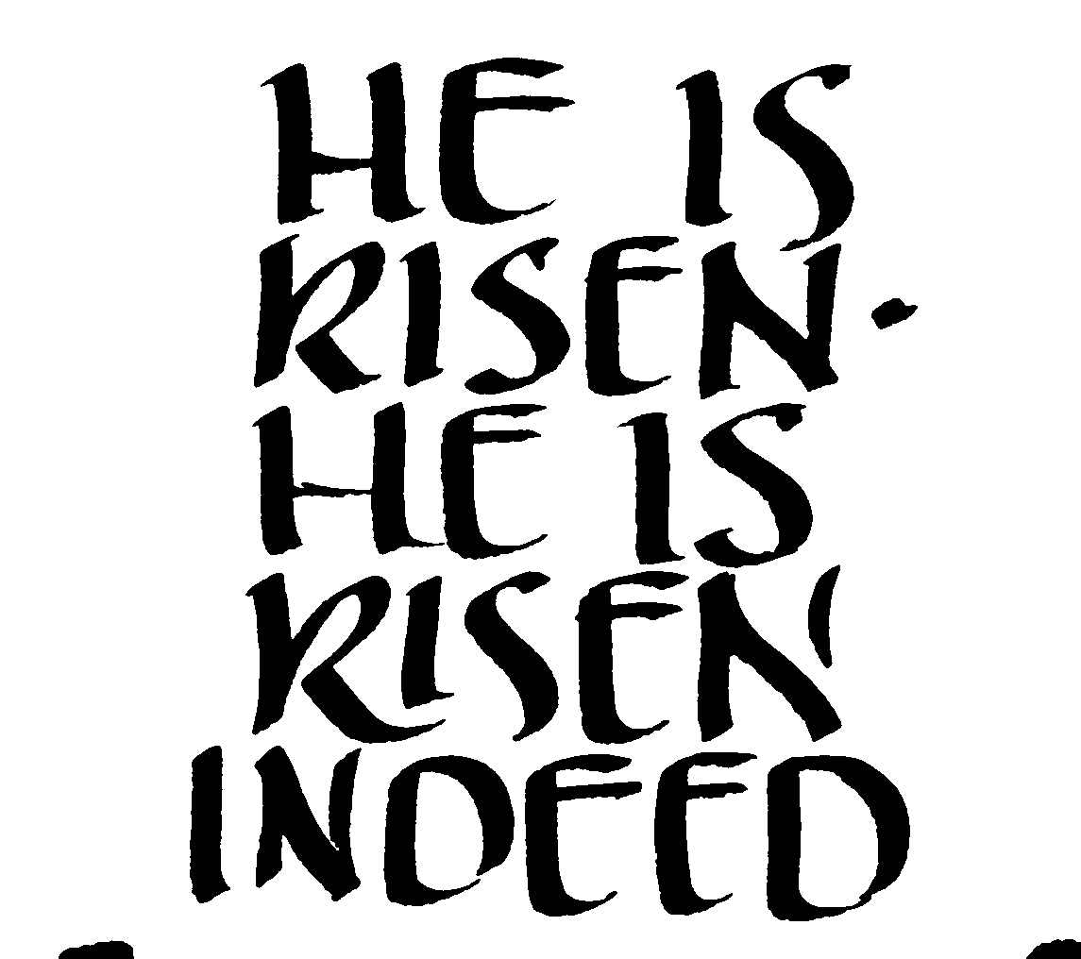
Day #5

Theme: We want the students to see that Jesus is not in His grave, but has risen from the dead.

Focus On: The Empty Tomb

Scripture: Luke 24: -11 (NIV)
¹On the first day of the week, very early in the morning, the women took the spices they had prepared and went to the tomb. ²They found the stone rolled away from the tomb, ³but when they entered, they did not find the body of the Lord Jesus. ⁴While they were wondering about this, suddenly two men in clothes that gleamed like lightning stood beside them. ⁵In their fright the women bowed down with their faces to the ground, but the men said to them, “Why do you look for the living among the dead? ⁶He is not here; he has risen! Remember how he told you, while he was still with you in Galilee: ⁷‘The Son of Man must be delivered into the hands of sinful men, be crucified and on the third day be raised again.’” ⁸Then they remembered his words.
⁹When they came back from the tomb, they told all these things to the Eleven and to all the others. ¹⁰It was Mary Magdalene, Joanna, Mary the mother of James, and the others with them who told this to the apostles. ¹¹But they did not believe the women, because their words seemed to them like nonsense.

Hymn: TLH #199
1. Jesus Christ Is risen today,
Students: Alleluia!
Our triumphant holy day,
Students: Alleluia!
Who did once upon the cross
Students: Alleluia!
Suffer to redeem our loss.
Students: Alleluia!

2. Hymns of praise, then, let us sing
Students: Alleluia!
Unto Christ, our heavenly King,
Students: Alleluia!
Who endured the cross and grave
Students: Alleluia!
Sinners to redeem and save.
Students: Alleluia!

3. But the pains which He endured
Students: Alleluia!
Our salvation have procured.
Students: Alleluia!
Now above the sky He's King,
Students: Alleluia!
Where the angels ever sing.
Students: Alleluia!

4. Sing we to our God above,
Students: Alleluia!
Praise eternal as His love:
Students: Alleluia!
Praise Him, all ye heavenly host,
Students: Alleluia!
Father, Son. and Holy Ghost.
Students: Alleluia!

Devotional Help:
You Will Need:
A glass half-filled with drinkable, colored liquid, e.g., juice, milk, or soft drink.
Lesson
We begin with an easy question: does this glass have something in it? The next question is a little harder. Is the glass half full, or is the glass half-empty. Different people give different answers to that question.
(Drink the contents of the glass.)
Now, let me ask again. Is the glass full or empty? I don’t think hardly anybody would say that this glass is full. But is it?
Some people, maybe some of you, who think like scientists might say the glass is still full. It’s not filled with (name of liquid.) What is it filled with? Yes, it’s filled with air.
You see, sometimes it’s hard to get people to agree on something that is right in front of their eyes.
It was no different when Jesus was on the earth. Jesus, the Savior, lived for us, suffered for us, and He died for us. Then, on the third day, He rose from the dead.
When some people who loved Him went to the cemetery they found His grave was empty. An angel even told them it was empty. If you had been there, yourself, you could have gone to Jesus’ grave and looked inside yourself. You could have looked as hard as you wanted, but you wouldn’t have found Jesus. That’s because Jesus was alive.
But, as I said, sometimes it’s hard to get people to agree… even when it’s right in front of their eyes.
There were people, that resurrection Sunday who didn’t believe Jesus was alive. There are still people who won’t believe that Jesus is alive. That’s very sad, indeed. You see, the devil wants them to shut their eyes and refuse to believe. Because, if they believe Jesus rose; then they will also have to believe Jesus is their Savior. I think they should open their eyes.
That’s why I’m a teacher. To help people see Jesus as their Savior. That’s why the pastor does what He does. That’s why your parents send you to this school. They want you to see the most important thing in the world: Jesus is risen.
Today, our friends on The Lutheran Hour tour are going to take a look at the church which was built over the spot where many people think Jesus was buried. It’s got a lot of gold and a lot of silver decorations that people have given. Why would they do that? Because they see Jesus is alive, and they wanted to do something to thank God.

Prayer:
Let’s finish with prayer, shall we? Dear Lord Jesus, we give thanks that You rose from the dead. May we always see that because You are alive, we will also live. We also ask that all those people who don’t see You very clearly, may have their hearts changed. May they look inside your tomb and see You have risen from the dead. In Your Name. Amen.

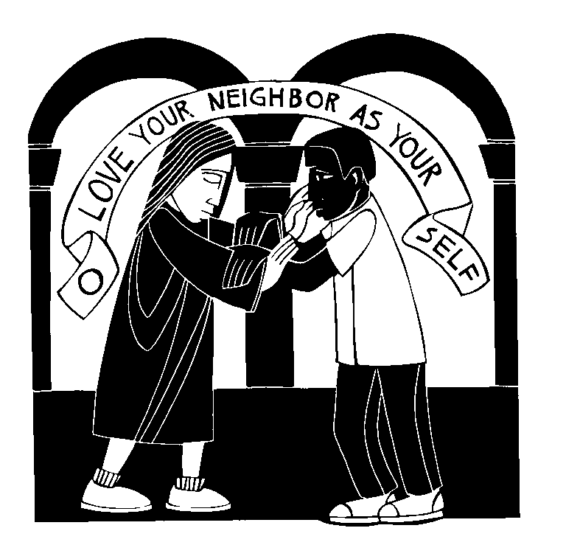
Day #6

Theme: The students will know that we are to love our neighbor as we do ourselves.

Focus On: Good Samaritan

Scripture: Luke 10: 25-37
²⁵On one occasion an expert in the law stood up to test Jesus. “Teacher,” he asked, “what must I do to inherit eternal life?” ²⁶“What is written in the Law?” he replied. “How do you read it?”
²⁷He answered: “‘Love the Lord your God with all your heart and with all your soul and with all your strength and with all your mind’ ; and, ‘Love your neighbor as yourself.’”
²⁸“You have answered correctly,” Jesus replied. “Do this and you will live.”
²⁹But he wanted to justify himself, so he asked Jesus, “And who is my neighbor?”
³⁰In reply Jesus said: “A man was going down from Jerusalem to Jericho, when he fell into the hands of robbers. They stripped him of his clothes, beat him and went away, leaving him half dead. ³¹A priest happened to be going down the same road, and when he saw the man, he passed by on the other side. ³²So too, a Levite, when he came to the place and saw him, passed by on the other side. ³³But a Samaritan, as he traveled, came where the man was; and when he saw him, he took pity on him. ³⁴He went to him and bandaged his wounds, pouring on oil and wine. Then he put the man on his own donkey, took him to an inn and took care of him. ³⁵The next day he took out two silver coins and gave them to the innkeeper. ‘Look after him,’ he said, ‘and when I return, I will reimburse you for any extra expense you may have.’
³⁶“Which of these three do you think was a neighbor to the man who fell into the hands of robbers?”
³⁷The expert in the law replied, “The one who had mercy on him.”
Jesus told him, “Go and do likewise.”

Hymn: TLH #396
1. Oh, for a faith that will not shrink
Tho' pressed by many a foe;
That will not tremble on the brink
Of poverty or woe;

2. That will not murmur nor complain
Beneath the chast'ning rod,
But in the hour of grief or pain
Can lean upon its God;

3. A faith that shines more bright and clear
When tempests rage without;
That, when in danger, knows no fear,
In darkness feels no doubt;

4. That bears unmoved the world's dread frown
Nor heeds its scornful smile;
That sin's wild ocean cannot drown
Nor Satan's arts beguile;

5. A faith that keeps the narrow way
Till life's last spark is fled
And with a pure and heavenly ray
Lights up the dying bed.

6. Lord give us such a faith as this;
And then, whate'er may come,
We'll taste e'en now the hallowed bliss
Of an eternal home.

Devotional Help:
YOU WILL NEED:
A list of student’s excuses. (Some are included in the body of the lesson. If you wish, add your own and write them down on various colored pieces of paper, as if they came from parents.)
The lesson
I know that all of you love homework, right? You love to get lots and lots of homework? You love getting homework so much that you would rather do homework than talk to your friends in the phone, or go outside and play, or watch TV or anything else, right?
I can remember back to when I was in school, and I didn’t like homework much, either. Sometimes you have to do homework, but that doesn’t mean it has to be on the top of the list of favorite things to do.
Some students I’ve heard about really don’t like homework. Rather than doing their homework, they came to school and gave the teacher a reason why they didn’t bring it with them. Let me ask, do you think these are good excuses, or bad excuses:
I lost my homework because I had to fight this kid you said you weren't the best teacher in the school. Good excuse, or bad?
I was held up by a robber on the way to school and the robber took everything I had. Good excuse, or bad?
Here’s one: Some aliens from outer space borrowed my homework so they could study how the human brain worked. If you were a teacher, would you believe that one?
I put it in a safe, but lost the combination. Good or bad excuse?
I loaned it to a friend, but he suddenly moved away. Good or bad excuse?
Our furnace stopped working and we had to burn it to stop ourselves from freezing. That one would only work in the wintertime, wouldn’t it.
I left it in my shirt and my mother put it in the washing machine. Is that a good excuse?
I didn't do it because I know how hard teachers work, and I didn’t want to add to your workload. Do you think a teacher would be happy with that excuse?
How about this one? Good excuse, or bad: A sudden gust of wind blew it out of my hand and I never saw it again
Another student, not from this school, fell in a lake, and I jumped in to rescue him but unfortunately my homework drown.. Good excuse or bad?
I didn't do it, because I didn't want the other kids in the class to look bad. I don’t think some of the other students in the class would like that one. Do you?
Excuses aren’t something new, are they? When Adam and Eve first sinned, they made excuses why they sinned, and people are still making excuses.
Jesus told about excuses, in a parable, a story, that He shared with His disciples. That story told about a man who was traveling down a road from Jerusalem to Jericho. In fact, that’s the same road our friends on The Lutheran Hour trip are taking today. We will be able to see what that road looks like in the pictures they send us. I hope the road is safer now.
As the man was traveling, he was mugged, beaten up and robbed. Shortly after, a man, who was kind of like a minister came by. You would think a minister would help. Ours sure would, but this minister didn’t help. He walked on by. Then another man came by. This man was sort of like a teacher. Now, all of our Teachers would help, but this one didn’t help, either. Both had their reasons why they didn’t help the hurt man. They weren’t good reasons, but they had reasons.
Finally, as that poor, beaten up man was lying there, a third fellow came by. Nobody expected this fellow to do anything. This man, with his friends, were enemies of the man who had been beaten up. But this man stopped. He helped his enemy. Made sure he had a doctor, and a place to stay and some food. He didn’t have any excuses.
Now which of those three people was really the friend of the man who had been beaten up. That’s what Jesus asked many years ago. It’s the question I’m asking today.
It’s the person who doesn’t have an excuse. The person who does what God wants them to do. No excuses to love God, or our neighbor. That’s the way it should be.

Prayer:
Dear Lord Jesus, You never had any excuses when it came to helping us. You always did what was right, even though people didn’t appreciate it, or say, “thank you.” Help us to do what is right when it comes to those around us. Help us to forget our excuses and take the love You have given us, and give it to all those around us. With no excuses, we ask this prayer in Your Name. Amen.

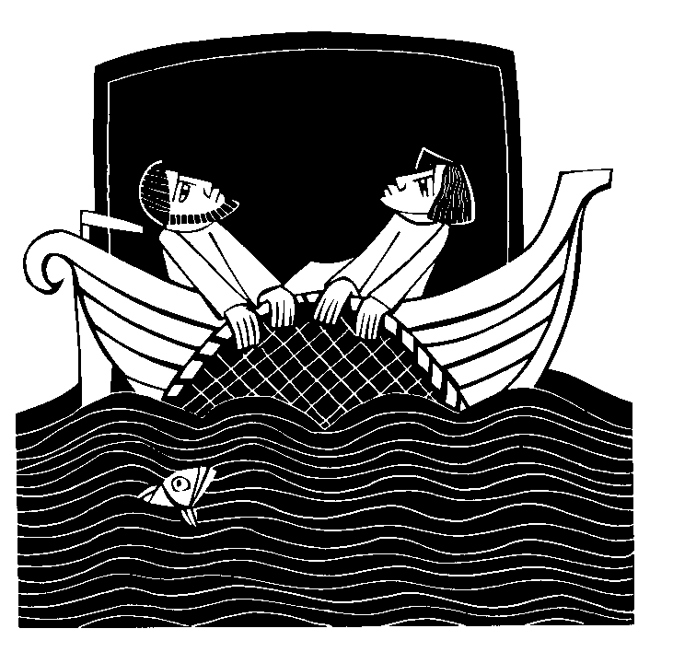
Day #7

Focus On: The Sea of Galilee

Theme: The student will see the wisdom of trusting the Lord.

Scripture: Luke 5: 1-11
¹One day as Jesus was standing by the Lake of Gennesaret, with the people crowding around him and listening to the word of God, ²he saw at the water’s edge two boats, left there by the fishermen, who were washing their nets. ³He got into one of the boats, the one belonging to Simon, and asked him to put out a little from shore. Then he sat down and taught the people from the boat.
⁴When he had finished speaking, he said to Simon, “Put out into deep water, and let down the nets for a catch.”
⁵Simon answered, “Master, we’ve worked hard all night and haven’t caught anything. But because you say so, I will let down the nets.”
⁶When they had done so, they caught such a large number of fish that their nets began to break. ⁷So they signaled their partners in the other boat to come and help them, and they came and filled both boats so full that they began to sink.
⁸When Simon Peter saw this, he fell at Jesus’ knees and said, “Go away from me, Lord; I am a sinful man!” ⁹For he and all his companions were astonished at the catch of fish they had taken, ¹⁰and so were James and John, the sons of Zebedee, Simon’s partners.
Then Jesus said to Simon, “Don’t be afraid; from now on you will catch men.” ¹¹So they pulled their boats up on shore, left everything and followed him.

Hymn: TLH #441
1. We give Thee but Thine own, Whate'er the gift may be;
All that we have is Thine alone, A trust, O Lord, from Thee.

2. May we Thy bounties thus As stewards true receive
And gladly, as Thou blessest us, To Thee our first-fruits give!

3. Oh, hearts are bruised and dead,
And homes are bare and cold,
And lambs for whom the Shepherd bled
Are straying from the fold.

4. To comfort and to bless, To find a balm for woe,
To tend the lone and fatherless, Is angels' work below.

5. The captive to release, To God the lost to bring,
To teach the way of life and peace, It is a Christ like thing.

6. And we believe Thy Word, Though dim our faith may be:
Whate'er for Thine we do, O Lord, We do it unto Thee.

Idea:

Devotional Help:
You Will Need:
Things that the children, and you, can’t explain how they work, e.g., a cell phone, a TV remote control, some plant food, etc.
The Lesson
How many years have you been in school? Going to school should teach you a lot of things. So that I could be your teacher, I went to school for a lot of years. I went to grade school, and high school and college. That’s more than ___ years. During all those years I learned a lot of things, but there are still some things I don’t know.
I don’t know how some things work. For example, even though I use a cell phone all the time, I’m not sure how the words I say here, go into the air, and are picked up somewhere, and manage to find their way to the person I’m trying to call.
And I don’t know how my TV remote control works. I know it sends out an infrared signal and that is picked up by my TV, and the TV turns on the channel I want. Or how it makes it LOUDER or softer. I don’t know why it works. I just know it does.
Some of you have seen me feed the plants in our room. This is the plant food I use. Now how a plant takes this stuff and eats it, when it doesn’t even have a mouth is something I don’t understand. I know our plants get what it needs through its roots, but I just don’t understand HOW that happens.
There are all kinds of things I don’t understand. That was true for some of Jesus’ disciples when they were fishing on the Sea of Galilee, many years ago. The Sea of Galilee is where The Lutheran Hour pilgrims are today. They’re taking a boat trip on the Sea.
Centuries ago, Jesus was on that same lake, and He told some of His friends to go fishing. Now, these friends of Jesus were fishermen. They knew what to do and what not to do, and they knew Jesus was telling them to fish all wrong.
Jesus wanted them to fish during the day, but they knew you should fish at night. Jesus told them to fish in the deep water, but they knew you catch fish in the shallow water. Jesus told them they would catch a lot of fish, but they hadn’t caught anything all night. They didn’t understand how, what Jesus was telling them, would work.
But they believed Jesus. They went out in their boats, into the deep water, and they caught so many fish that their boats couldn’t hold them all without starting to sink. That was a miracle.
God does a lot of miracles for us. Even today. No, not usually with fish, but He does things we don’t understand. I don’t understand why He loves sinners, but He does. And I don’t understand why Jesus came to save me, but He does. And I don’t understand how baptism washes away my sins, but it does. I don’t know a lot of things, but I believe God, and I believe He does what is best for me.
That’s what we call “faith.” Believing without understanding. That’s the way God’s people live their lives. In faith.

Prayer:
Dear Lord, we give thanks that You understand how much we need You. We could never be forgiven, or saved, or be really happy if Jesus hadn’t come to save us. We don’t understand why You have loved us so much, but we appreciate it more than we can say. Help us always be thankful for salvation, even if we don’t understand everything. In Jesus’ Name. Amen.

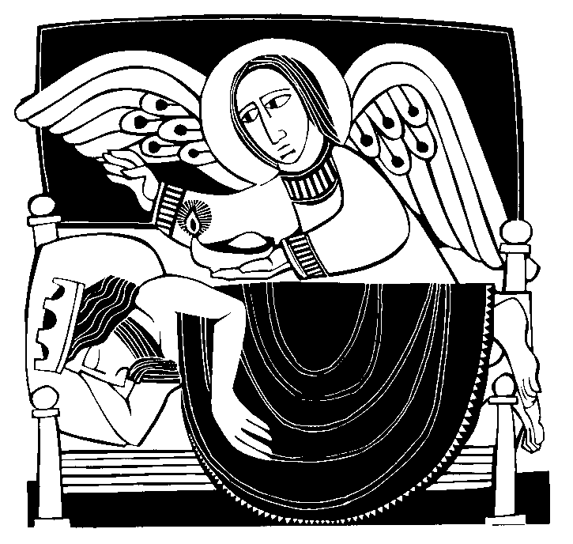
Day #8

Focus On: A King Who was Too Proud

Theme: The students will understand that all we have comes from the Lord.

Scripture: Acts 12: 19b-24
Then Herod went from Judea to Caesarea and stayed there a while. ²⁰He had been quarreling with the people of Tyre and Sidon; they now joined together and sought an audience with him. Having secured the support of Blastus, a trusted personal servant of the king, they asked for peace, because they depended on the king’s country for their food supply.
²¹On the appointed day Herod, wearing his royal robes, sat on his throne and delivered a public address to the people. ²²They shouted, “This is the voice of a god, not of a man.” ²³Immediately, because Herod did not give praise to God, an angel of the Lord struck him down, and he was eaten by worms and died.
²⁴But the word of God continued to increase and spread.

Hymn: TLH #575
Before the Lord we bow,
The God who reigns above
And rules the world below
In boundless pow'r and love.
Our thanks we bring, In joy and praise
Our hearts we raise To heav'n's high King.

2. The nation Thou hast blest
May well Thy love declare,
From foes and fears at rest, Protected by Thy care.
For this fair land, For this bright day,
Our thanks we pay-- Gifts of Thy hand.

3. May ev'ry mountain height,
Each vale and forest green,
Shine in Thy Word's pure light
And its rich fruits be seen! May ev'ry tongue
Be tuned to praise And join to raise
A grateful song!

4. Earth, hear thy Maker's voice,
Thy great Redeemer own;
Believe, obey, rejoice,
And worship Him alone.
Cast down thy pride, Thy sin deplore,
And bow before The Crucified.

5. And when in power He comes,
Oh, may our native land
From all its rending tombs
Send forth a glorious band, A countless throng,
For aye to sing To heaven's high King Salvation's song!

Devotional Help:
You Will Need
A picture of the Olympic rings. (one is included at the end of the booklet.) The Olympic motto (also included.)
The Lesson
This Summer, the world played some games. Does anybody remember what those games were called? Exactly! And what is this called? This is the symbol of the Olympics. It is called the Olympic rings.
Now, the next question is harder. Do you know what the rings stand for? The man who restarted the Olympic Games, in 1913 designed them…but what do they stand for? They represent the five major regions of the world: Africa, the Americas, Asia, Europe and Oceania. Every nation of the world has one of the colors of the Olympic rings in its flag. Now you know.
Now, let me ask the hardest question of all: what is the motto of the Olympic games? I’ll give you a clue. It is three Latin words. I didn’t expect anybody to know. Most of us don’t know Latin, do we. The three words are: "Citius (say: city-us), Altius (say: all-tee-us), Fortius (say four-tee-us)." Thos words mean “Swifter, Higher, Stronger.”
That’s kind of what the Olympics are all about. We want to find who is the fastest, who can go the highest, who is the strongest. We want to find out who is the best in the whole world. At least for that day.
You know, it’s pretty hard, when you’re the best at something, not to walk around and say, “I’m the greatest… I’m the best… and you’re not.” That’s hardly the way we should be. Not us, or anybody. After all, everything we are, and have, is a gift from God.
In the Bible we have the story of a king who kind of thought he was the best. People told him he was, and he believed it. He was a king, which meant he was powerful. One day he went to a theater, which was out in the open… a very pretty spot… our friends at The Lutheran Hour who are over there are going to show us pictures of the theater.
At any rate, the king went to the theater, and he wore his best clothes. All shiny, and silvery. And he came into the theater and the sun just beamed off his robes and the people said, “Wow, you’re so great, you’re a god.” And he didn’t say, “No, I’m just a king. He didn’t say, “You should praise Jesus.” No, he just smiled and acted like he was the best in the entire world.
And he died. As he died, he said it was a punishment because he hadn’t given God glory. Because he thought he, not God, was the best.
You know, we have some very special people in our class. We have some people who are very smart, and some who are very fast, and some who can jump very high, and some who can write very well, and some who can be wonderful friends, and some who know how to smile and make us feel good. We have some wonderful people here, who can do wonderful things.
But I hope that, as you do wonderful things, that you always remember to thank the Lord. He’s the One who has given us the ability to run, not everybody has that…. Or to do arithmetic problems (not everybody can do that), or smile real nice, or be a good friend, or….
God has given us everything we have. He is the Best, and we need to say, “Thank You, Lord for make me who I am.”

Prayer:
Dear Lord, You have made me special. There are some things that I can do well, and some that I need to work on. Help me, wherever I go, whatever I do, always to remember to give thanks to You. Help me let other people know that they are special, too. That’s what Jesus did. That’s what I want to do, too. In Jesus’ Name I give thanks today. Amen.

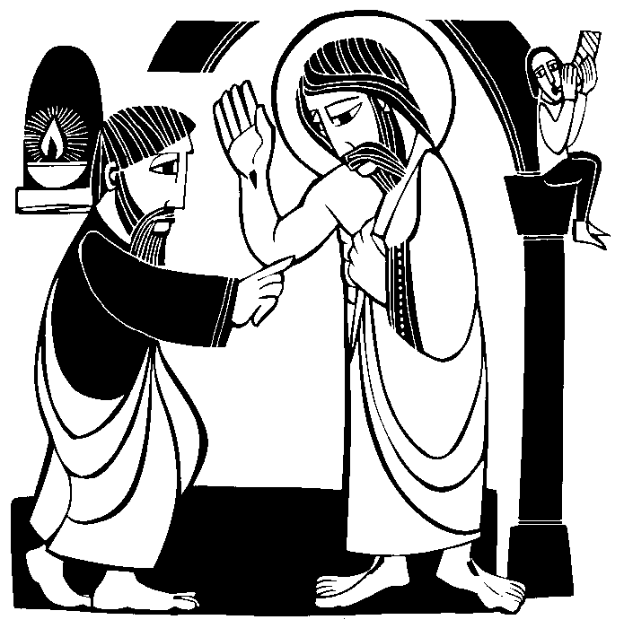
Day #9

Focus On: Seeing The Savior

Theme: The students will understand the Savior has risen, and we may believe it.

Scripture: John 20: 24-28
24Now Thomas (called Didymus), one of the Twelve, was not with the disciples when Jesus came. 25So the other disciples told him, “We have seen the Lord!”
But he said to them, “Unless I see the nail marks in his hands and put my finger where the nails were, and put my hand into his side, I will not believe it.”
26A week later his disciples were in the house again, and Thomas was with them. Though the doors were locked, Jesus came and stood among them and said, “Peace be with you!”
27Then he said to Thomas, “Put your finger here; see my hands. Reach out your hand and put it into my side. Stop doubting and believe.”
28Thomas said to him, “My Lord and my God!”

Hymn: TLH #381
1. I know my faith is founded
On Jesus Christ, my God and Lord;
And this my faith confessing
Unmoved I stand upon His Word.
Man's reason cannot fathom
The truth of God profound;
Who trusts her subtle wisdom Relies on shifting ground.
God's Word is all-sufficient, It makes divinely sure,
And trusting in its wisdom, My faith shall rest secure.

2. Increase my faith, dear Savior,
For Satan seeks by night and day
To rob me of this treasure
And take my hope of bliss away.
But, Lord, with Thee beside me, I shall be undismayed;
And led by Thy good Spirit,
I shall be unafraid. Abide with me, O Savior,
A firmer faith bestow; Then I shall bid defiance
To every evil foe.

3. In faith, Lord, let me serve Thee;
Though persecution, grief and pain
Should seek to overwhelm me,
Let me a steadfast trust retain; And then at my departure
Take Thou me home to Thee
And let me there inherit All thou hast promised me.
In life and death, Lord, keep me
Until Thy heaven I gain, Where I by Thy great mercy
The end of faith attain.

Devotional Help:
You will need:
Some optical illusions There are a few included at the end of our booklet. If it is a help, blow them up so the class can see them more clearly. You may wish to give each student a copy of the illusions.
The Lesson
Some of us wear glasses. Some of us don’t. One thing we all want is to see things clearly. Today I’m going to check to make sure you see things clearly.
Here is a sign. Can you read it? What does it say? Most people will say “A bird in the bush.” (The sign actually reads, “A Bird in the THE bush.”) Look carefully. You want to see things clearly. (Somebody will get it right. Congratulate them.)
Here’s another picture. Can you tell me what it is. Some people will see a rabbit. Other people will see a duck. Can you see both of them?
Here’s an optical illusion. How many legs does the elephant have. You and I know that an elephant has four legs, but this one seems to have five. Count them.
Here’s one that’s really tough. How many black dots do you see in this picture? Well our eyes say there are a lot of them, but really, there’s not a single black dot in the picture.
The last optical illusion I’m showing you is this one. Is it the face of a person, or is it an Eskimo. It could be both, it could be either.
Sometimes our eyes play tricks on us, don’t they.
In the time of Jesus, one of His disciples thought his friends eyes were playing tricks on them. They said that Jesus had risen from the dead. He knew that couldn’t happen. That’s not the kind of thing that dead people do. This disciple, his name was Thomas, said, ‘I have to see for myself. I want to see Jesus. I want to see His hands where the nail wounds were. I want to see His side where the soldier stabbed Him with a spear. I want to see.’
Well, Jesus let that disciple see. He showed Himself to Thomas and said, ‘See, take a look at My hands and My side.’ And Thomas saw. When He had seen Jesus, he realized it wasn’t an optical illusion. He knew that Jesus had really risen from the dead. And the disciple believed.
Then Jesus said, ‘blessed are the people who believe, without seeing.’ Jesus meant us.
We don’t get to see Jesus’ hands, or His feet. All we can do is believe. Our friends who have been traveling with The Lutheran Hour, know that. They believe in Jesus, just like we do. They have helped us see where He was born, and where He died, and where He did some of His miracles. We are glad to see those things… but we always have to remember, we believe in Jesus through our faith.
Oh, and we also believe, because He is with us always. We can’t see Him, but He’s there. And that’s no optical illusion, or something imaginary. Jesus is alive, real, and with us. For that we give thanks.

Prayer:
Dear Lord Jesus, we give thanks that You are alive. Because You live, we know that we will live forever. We give thanks that we have seen some of the places You lived and walked and did miracles. We also give thanks that we don’t have to see You in order to believe. Help us always believe. In Your Name. Amen.

ENDNOTE – The story of Herod Agrippa is told in the Bible. It was also told by the Jewish Historian, Josephus. What follows here is his account:

Now when Agrippa had reigned three years over all Judea, he came to the city Cesarea, which was formerly called Strato’s Tower; and there he exhibited shows in honor of Caesar, upon his being informed that there was a certain festival celebrated to make vows for his safety. At which festival a great multitude was gotten together of the principal persons, and such as were of dignity through his province. On the second day of which shows he put on a garment made wholly of silver, and of a contexture truly wonderful, and came into the theater early in the morning; at which time the silver of his garment being illuminated by the fresh reflection of the sun’s rays upon it, shone out after a surprising manner, and was so resplendent as to spread a horror over those that looked intently upon him; and presently his flatterers cried out, one from one place, and another from another, (though not for his good), that he was a god; and they added, “Be thou merciful to us; for although we have hitherto reverenced thee only as a man, yet shall we henceforth own thee as superior to mortal nature.” Upon this the king did neither rebuke them, nor reject their impious flattery. But as he presently afterward looked up, he saw an owlAnt-19-22 sitting on a certain rope over his head, and immediately understood that this bird was the messenger of ill tidings, as it had once been the messenger of good tidings to him; and fell into the deepest sorrow. A severe pain also arose in his belly, and began in a most violent manner. He therefore looked upon his friends, and said, “I, whom you call a god, am commanded presently to depart this life; while Providence thus reproves the lying words you just now said to me; and I, who was by you called immortal, am immediately to be hurried away by death. But I am bound to accept of what Providence allots, as it pleases God; for we have by no means lived ill, but in a splendid and happy manner.” When he said this, his pain was become violent. Accordingly he was carried into the palace, and the rumor went abroad every where, that he would certainly die in a little time. But the multitude presently sat in sackcloth, with their wives and children, after the law of their country, and besought God for the king’s recovery. All places were also full of mourning and lamentation. Now the king rested in a high chamber, and as he saw them below lying prostrate on the ground, he could not himself forbear weeping. And when he had been quite worn out by the pain in his belly for five days, he departed this life, being in the fifty-fourth year of his age, and in the seventh year of his reign; for he reigned four years under Caius Caesar, three of them were over Philip’s tetrarchy only, and on the fourth he had that of Herod added to it; and he reigned, besides those, three years under the reign of Claudius Caesar; in which time he reigned over the forementioned countries, and also had Judea added to them, as well as Samaria and Cesarea.
Josephus The Antiquities of the Jews; Book 19, Chapter 8, Sections 1-3



Endnote: Here are some optical illusions






ENDNOTE – Here are the OLYMPIC RINGS



ENDNOTE – More on Qumram
The Qumran site that our tour is visiting, has no direct relationship with the life of the Savior. It does, however, speak to the preservation of God’s Holy Word. The Qumram location was used for about 200 years, beginning around 130 years before Christ. Qumram is 8 miles south of Jericho and about ¾ of a mile from the northwest edge of the Dead Sea.
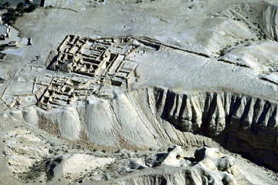
It is assumed that the community was occupied by a group of Essenes. Living a monastic life, (although they were allowed to marry), everything they did was dedicated to following the Lord’s will in their lives. Avoiding contact with the outside world, the Qumram community spent much of their energy in the copying, and studying of Scripture.
Figure 1 - Qumram from the air
During the Jewish revolt, with the Roman army approaching, the community hid their manuscripts in some of the surrounding caves.
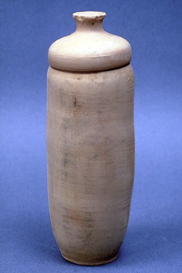
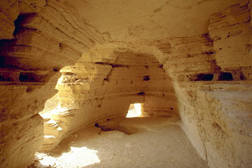
In 1947, a Bedouin shepherd boy, looking for one of his strays, threw a stone into one of these caves, heard some pottery smash and found the scrolls. Some of the manuscripts were close to 1,000 years older than what we had. Amazingly, when they were compared, there was no fundamental differences in the text. Thus had God preserved His Scriptures for us.
Figure 2 - Type of jar containing scrolls
Figure 3 - Inside Scroll Cave #4

